Policy Name | Research Ethics and Integrity Policy
Proposed By | Director ORIC
Reviewed By | Registrar and Pro-VC
Approved By | ORIC Steering Committee
Effective From | 01-07-2026
Next Review Date | 30-06-2028
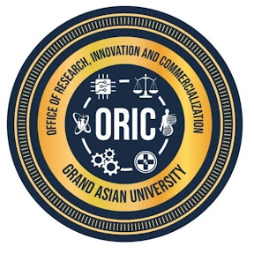
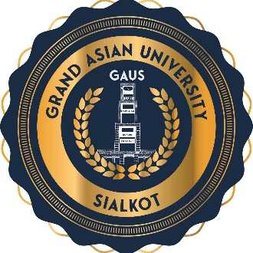
- Purpose
The purpose of this policy is to establish a framework that promotes ethical, responsible, and transparent research practices at Grand Asian University. The policy aims to safeguard the dignity, rights, safety, and welfare of research participants while ensuring the integrity, credibility, and quality of all research conducted under the University’s auspices.
- Scope
This policy applies to all research activities conducted under the auspices Islam Group and Grand Asian University irrespective of the source of funding, location of the research, or disciplinary area. It is applicable to faculty members, researchers, students, research staff, visiting scholars, consultants, and all individuals engaged in research on behalf of the University.
- Policy Statement
Grand Asian University recognizes that research integrity is fundamental to academic excellence and the advancement of knowledge. The University expects all researchers to conduct their work in a manner that respects human dignity, protects the welfare of research participants, ensures the humane treatment of animals where applicable, preserves environmental sustainability, and maintains the highest standards of scientific rigor. Research outcomes shall be reported accurately and honestly without fabrication, falsification, selective reporting, or any practice that may compromise the integrity of scholarly work.
- Principles of Research Ethics and Integrity
Research conducted at the University shall be guided by the following principles:
- Honesty in proposing, conducting, and reporting research.
- Accuracy in data collection, analysis, and interpretation.
- Transparency in research methods and reporting.
- Accountability for research practices and outcomes.
- Respect for human participants, animals, communities, and the environment.
- Fairness in authorship, peer review, and collaboration.
- Confidentiality of research data and participants.
- Compliance with applicable laws, regulations, and institutional policies.

- Ethical Conduct of Research
Every research project undertaken at Grand Asian University shall be designed and implemented in a manner that reflects scientific rigor and ethical responsibility. Researchers are expected to obtain all necessary institutional approvals before initiating research involving human participants, animals, hazardous materials, or environmentally sensitive activities.
Participation in research shall be voluntary and based upon informed consent obtained without coercion or undue influence. Researchers should ensure that participants are adequately informed about the objectives of the study, potential risks and benefits, confidentiality arrangements, and their right to withdraw from the research at any stage without penalty.
- Roles and Responsibilities
The promotion of ethical research is a collective institutional responsibility. The University should provide an enabling environment through clear policies, appropriate governance structures, adequate resources, and continuous professional development opportunities. The Office of Research, Innovation and Commercialization (ORIC) shall coordinate institutional efforts to strengthen research ethics by facilitating ethical review processes, maintaining institutional records, and organizing awareness programs.
Faculty members shall demonstrate leadership by modelling ethical behavior, mentoring students and early-career researchers, and promoting responsible research practices. Students shall conduct their research responsibly, comply with approved protocols, respect the rights of research participants, and maintain academic honesty in all scholarly activities.
- Monitoring and Compliance
The implementation of this policy shall be monitored by ORIC in collaboration with the Institutional Review Board and other relevant statutory bodies of the University. Any breach of this policy shall be addressed through established institutional procedures. Depending on the nature and severity of the violation, corrective measures may include mandatory training, withdrawal of ethical approval, suspension of research activities, disciplinary action, or referral to relevant statutory authorities.
- Policy Review and Amendments
This policy shall be reviewed every two years, or earlier if required, to ensure alignment with the University's strategic priorities, HEC regulations, emerging technologies, and best international practices. Amendments shall be approved by the appropriate statutory bodies of the University.
Proposed By: Approved By:

Director ORIC Vice Chancellor/ Chairman ORIC-SC
Grand Asian University Sialkot Grand Asian University Sialkot

